Steven Raaijmakers, 10804242. Ubuntu 16.04

Task 1

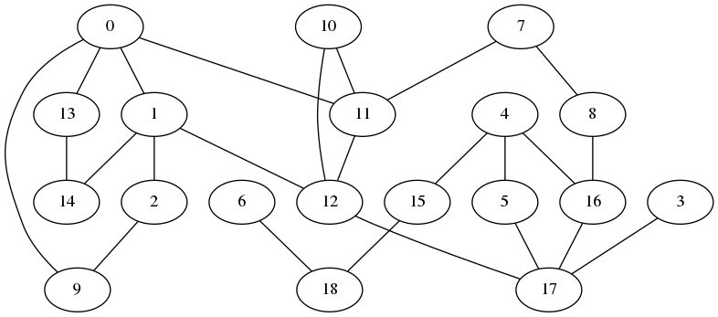
Task 2
1. [0, 1, 12, 17, 16, 4]
2. ['Adelaide1', 'Adelaide2', 'Melbourne2', 'Sydney2', 'Sydney1', 'Brisbane1']
3.
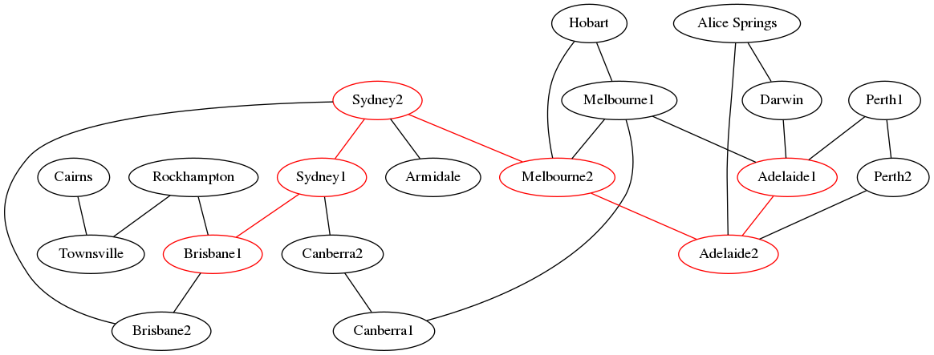
Task 3
1. Diameter: 6104.68192596 km
2. ['Darwin', 'Adelaide1', 'Adelaide2', 'Melbourne2', 'Sydney2', 'Sydney1', 'Brisbane1', 'Rockhampton', 'Townsville', 'Cairns']
3. 64

Task 4
1. Yes it does, it changes a little to 6104.69251408 km
2. X

